**Section 7 - Hydrogen Rotary Engine**

**Section 7.1 - Development of Hydrogen Rotary Engine Vehicle**

**Section 7.1.1 - Abstract**

A hydrogen ice (internal combustion engine) vehicle was sent to the Japanese market in 2006 with what is known as a hydrogen rotary engine fuelled by 35MPa compressed-hydrogen. Mazda continued development with this particular engine as a project with a primary purpose to research and develop a prototype like vehicle with this engine.

**Section 7.1.2 - Introduction**

Mazda's hydrogen rotary engine, which is based on the previously described unique rotary engine technology, has been converted to run on hydrogen, which generates no CO2 and has excellent environmental performance.

Mazda was able to produce hydrogen-fuelled rotary engine vehicles at a reasonable cost because the rotary engine only required a few design adjustments to operate on hydrogen.

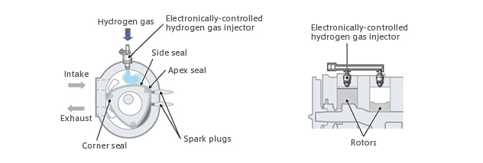

*Figure 1 - Outline of Hydrogen Rotary Engine*

[*Image Source*](https://www.mazda.com/en/innovation/technology/env/hre/)

**Section 7.1.3 - Specifications**

Direct injection is used in the hydrogen rotary engine, using an electronically controlled hydrogen gas injector.

The hydrogen filler valve is the one commonly used in gas mobile motors, positioned on the opposite aspect of the gasoline filler valve on the base vehicle.

With an electronically-controlled hydrogen gas injector mounted on the top of the rotor housing, this system takes air in from a side port and injects hydrogen straight into the intake chamber.

[Video Source](https://www.youtube.com/watch?v=ytt68ANGksE)

**Section 7.2 - RX-8 Hydrogen RE**

**Section 7.2.1 Overview**

The Mazda RX-8 Hydrogen RE, was advanced and commercialized by way of Mazda, and is the world's first practical implementation of a hydrogen rotary engine automobile.

The vehicle is stated to operate without compromising the sensations of torque and acceleration nor the exhaust sound, observe particular to internal combustion engines. Furthermore, it emits no CO2 and nearly no NOx making it the last “green” vehicle.

[Video Source](https://www.youtube.com/watch?v=F16vYjWy6cw)

**Section 7.2.2 Society & Applications**

In Japan, the automobile has been offered for hire to nearby governments and establishments in 2006.

In 2008 Mazda commenced to participate within the Norwegian hydrogen dual carriageway task “HyNor.”

**Section 7.3 - Advantages**

In addition, the vehicle has a 'dual-fuel' system that allows it to run on either gasoline or hydrogen.

The driver does not have to worry about running out of hydrogen, which makes the automobile more handy because it can go long distances to locations where hydrogen stations are not available.

Seating capability of four adults has been maintained from the base automobile, with two hydrogen tanks installed within the trunk.

The RE structure has no intake and exhaust valves, and therefore the low-temperature intake chamber and high-temperature combustion chamber are separated.

This allows smart combustion and helps avoid backfiring.  
  
Further, the RE encourages thorough intermixture of **H**and air since the period of the intake method is longer than in reciprocal engines.

**Section 7.4 - Premacy Hydrogen Rotary Hybrid**

**The Premacy Hydrogen Rotary Hybrid is a vehicle produced by Mazda that combines the hydrogen rotary engine with a hybrid system for improved performance and practicality.**

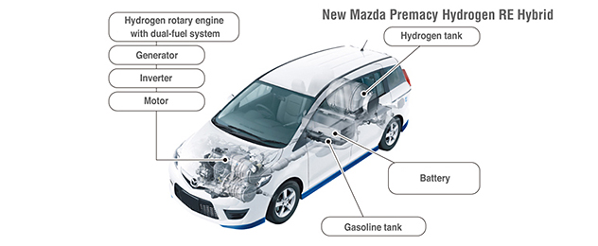

*Figure 2 - Layout of a Premacy Hydrogen Rotary Hybrid*

[*Image Source*](https://www.mazda.com/en/innovation/technology/env/hre/)

The Premacy chemical element RE Hybrid produces roughly 40% a lot of power than the Mazda RX-8 chemical element RE, leading to considerably increased acceleration.The hybrid system expeditiously converts the chemical element combustion energy to electricity, that drives the wheels via an electrical motor.Being a Premacy, it's conjointly a lot of easy than the RX-8 chemical element RE, providing larger cargo housing and seating for five adults.As a result, drivers can expect low fuel consumption also as direct feel a powerful ride, and driving range of 200 kilometres on hydrogen fuel.For even greater range, the model is provided with Mazda's 'dual-fuel' system that permits the automobile run on multiple fuelling materials such as gasoline and hydrogen.The heart of the vehicle, the engine, is switched from a longitudinal to a transversal layout.

**Section 7.5 - Conclusion**

In summary, lean burn and exhaust gas recirculation (EGR) are employed in the design of this hydrogen rotary engine, reducing nitrogen oxide (NOx) emissions, being one of the most impactful aspects of this project on both the engineering world and society/the public.

The hydrogen vehicle has been created in achieving usability at a low cost, hoping that it contributes to realization of a hydrogen society or the potential to utilize and employ hydrogen as fuel.

Such a development proves the practicality of hydrogen vehicles. Disadvantages around transport and storage of hydrogen are still unsolved, such as the space occupied and lower driving range in comparison to standard gasoline powered or fuelled vehicles.

Mazda has stated within their research paper or document that they would, "like to continuously and positively work with other hydrogen researchers to tackle these issues." (MAZDA: Hydrogen Vehicles - Environmental Technology, n.d.)

Dual fuel system can cover the hydrogen storage issue. The vehicle meets the severe standard of emissions and the fuel efficiency and is better than that of gasoline with its displayed results.  However, development on further driving range is desirable.

**References:**

[1] - Morimoto Kenji, etal., Development of hydrogen vehicle, Mazda Technical Review, No.14, page154-161  
(1996)

[2] - mazda.com. n.d. *MAZDA: Hydrogen Vehicles - Environmental Technology*. [online] Available at: <https://www.mazda.com/en/innovation/technology/env/hre/> [Accessed 23 May 2021].